sn | Speaker | Photo | Profile
1 | Lyn Boxall | 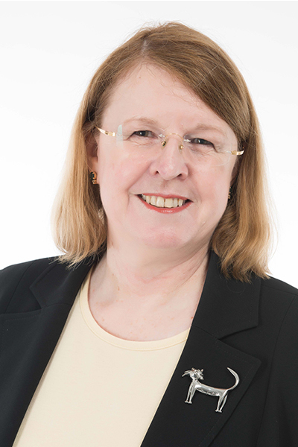 | After 16 years living in Singapore and mostly working for MNCs, Lyn Boxall established her own Singapore law firm in March 2015 (Lyn Boxall LLC). She helps business clients build their businesses in an efficient and ethical way. She sees the law as a activator and enabler of business. But she also believes that the law should be understandable by individuals who are affected by it – that the law should be helping people and not confusing them. This is the reason why Lyn has been a strong advocate for many years of ‘plain English’ for legal documents and for legal advice.  Lyn has a strong interest in fairness for individuals in all walks of life. She supports consumer rights and protection from harassment, especially in the workplace.  She also works extensively on data protection/privacy from the perspective of both individuals and businesses. These are all things that can help individuals have control over their own life and to treated fairly by both businesses and other individuals.
2 | Darren Chan | 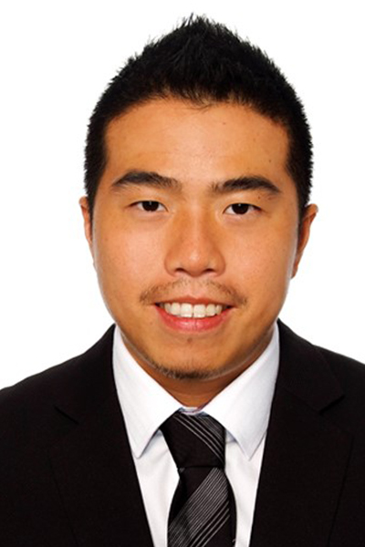 | Darren Chan is a Senior Associate in Fortis Law Corporation and a member of the Firm’s Private Client Practice Group.  He has represented clients in various litigation matters including medical negligence, contractual claims, debt recovery and matrimonial disputes. Darren specialises in family law. These include divorce proceedings, ancillary matters (e.g. arrangements for the children, asset division and maintenance), mediation, as well as Court applications for discovery, personal protection order, variation and enforcement of Court orders. He also handles non-contentious work such as drafting pre-nuptial agreements, divorce agreements and wills.  Darren has a Bachelor of Laws (Hons) from the University of Leicester.  Darren is admitted as an Advocate and Solicitor in Singapore and speaks English, Malay, Mandarin, Japanese and French
3 | Michael Chen | 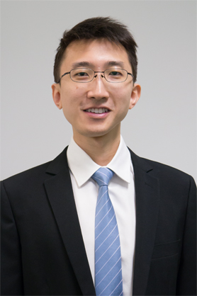 | Michael practices in the area of Technology, Media and Telecoms. He has assisted in an extensive range of intellectual property, technology, media, and data protection matters. He actively advises on a wide range of technology contracts.  He graduated from the University of Melbourne Law School and is admitted in both Singapore and Australia. Michael has a keen interest in computers and technology, and also holds a degree in electrical and computer engineering from Cornell University.
4 | Rajan Chettiar | 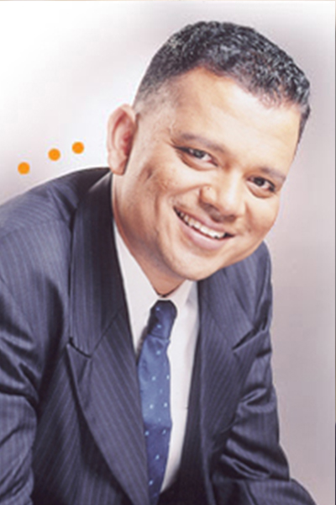 | After having qualified as a barrister-at-law in England and admitted to the Singapore Bar in March 1997, Rajan Chettiar worked in one of the oldest and prestigious law firm in Singapore. Having caught the entrepreneur bug and a strong desire to use his legal skills to assist individuals, he then set up the firm of Rajan Chettiar & Co in 2003 which specialises in all aspects of family and personal laws.  He is currently the Managing Director of Rajan Chettiar LLC. Besides family law, Rajan also practices in the areas of employment, criminal, commercial and conveyancing laws. He is one of the first two collaborative family lawyers in Singapore.  He is an Associate Mediator of the Singapore Mediation Centre and a Court appointed volunteer mediator of the State Courts, Family Justice Court in Singapore and the Community Mediation Centre. Besides legal work, Rajan is also involved in the social services scene since 1990. He was a Board member of SPD (the Society For the Physically Disabled) and is a legal advisor to the Centre For Family Harmony, a voluntary welfare organization which provides child access services to divorced parents.
5 | Chua Jian Zhi | 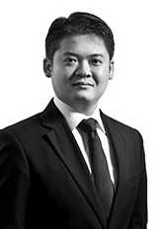 | Jian Zhi is an Associate in the Litigation and Dispute Management and Restructuring and Insolvency Teams in the Singapore office specialising in corporate and individual insolvency, asset recovery and restructuring. He also works with the Construction and Engineering team and has experience in construction-related dispute resolution and advisory work.  His recent experience includes advising:  - foreign venture capitalist, investors, directors and shareholders on insolvency issues and the debt restructuring of the insolvent subsidiaries of a private company.  - a group of Medium Term Notes Holders in a contested Singapore High Court application between a Scheme Manager and the Company in assessing further professional fees payable to the Scheme Manager pursuant to a value added formula.  - a consultant on various aspects of a large-scale port development project and the Public Sector Standard Conditions of Contract (PSSCOC).  In the area of asset recovery litigation, Jian Zhi has advised and acted for companies, directors, creditors, liquidators, private trustees, commercial landlords and banks in Court proceedings as well as enforcement proceedings including bankruptcy, company winding up, examination of judgment debtor, garnishee proceedings, writ of distress and writ of seizure and sale. Jian Zhi also regularly advises clients on other contractual remedies including re-entry and repossession of premises.  In the area of construction-related advisory work and disputes resolution, Jian Zhi has advised and acted for property developers, builders and contractors, management corporations and managing agents on matters involving the Land Titles Act, Land Titles (Strata) Act and Building Maintenance and Strata Management Act (BMSMA) including assisting in arbitration proceedings in the Strata Titles Boards.  Jian Zhi has also advised on construction contracts including the Public Sector Standard Conditions of Contract (PSSCOC), the Singapore Institute of Architects Lump Sum Contract (SIA Lump Sum Contract) and the SIA Articles and Conditions of Contract for Minor Works 2012 (SIACMW).  Jian Zhi also volunteers regularly with the Pro Bono Services Office of The Law Society of Singapore including acting as Volunteer Counsel for the Criminal Legal Aid Scheme (CLAS), sharing on legal topics at community events, as well as advising both community organisations as well as individuals at legal clinics.  Jian Zhi is qualified as an Advocate and Solicitor of the Supreme Court of Singapore and has also been admitted as a Member of the Singapore Institute of Arbitrators (SIArb).
6 | Foo Juyuan | 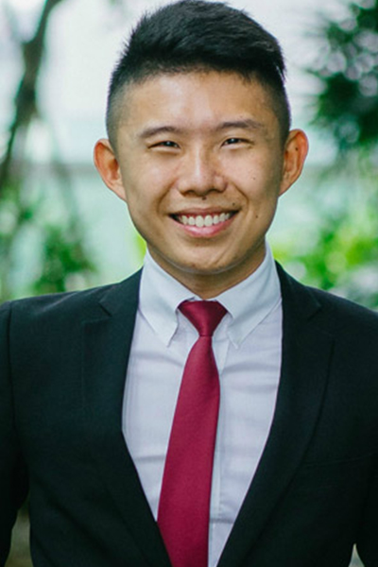 | Juyuan is an associate at Eden Law Corporation. Juyuan believes that everybody, young or old, rich or poor, should at the very least, be able to easily understand their basic rights and have access to legal advice.  Juyuan was admitted as an Advocate and Solicitor of the Supreme Court of Singapore in 2014. He has extensive experience in matrimonial matters and criminal defence litigation. Juyuan was one of the five pioneer Criminal Legal Aid Scheme Fellows in 2015.
7 | Elaine Ho | 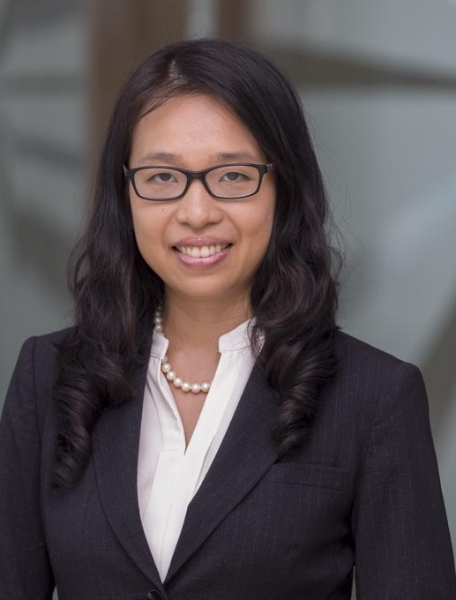 | Elaine Ho is a transactions lawyer qualified in 3 jurisdictions (England and Wales, New York and Singapore) with substantial experience in banking and finance, funds, mergers and acquisitions as well as regulatory matters. She has recently joined a global agricultural trading company as in-house legal counsel for its financial services group after over a decade of experience with major international law firms. Prior to that she trained in a large Singapore firm.  Elaine has advised global and regional banks, financial institutions and corporates in various capacities in financings and restructurings involving syndicated loans, real estate finance, acquisition finance, pre-export finance, subscription credit facility, convertible notes and derivatives. In her current role, she has a strong trade finance focus. She has also acted on fund formation matters for managers of hedge funds and private equity funds, and provided regulatory advice to multinational corporations in various areas including anti-money laundering, data protection, employment and advertising.  Elaine is also an active contributor to the community, serving as chairperson of the Ageing Gracefully at Home project launched in Chinatown aimed at improving healthcare and quality of life of the elderly immobile living alone in the Chinatown rental flats, and also in various other capacities in other community organisations. She also sits on the Law Society’s Law Awareness Committee and Community Legal Clinics Committee.
8 | Stephanie Hong |  | Stephanie is one of the founding Directors of Lexton Law Corporation. She graduated with 2nd Class (Upper) Honours in Law from the National University of Singapore and has been a practicing lawyer, engaged in both contentious and non-contentious legal work, since 1996.  Her practice areas include (a) transactions in the conveyance of real estate and advice in relation to securities and disputes arising thereto, drafting and negotiations of leases, (b) civil and commercial litigation and advisory work in relation to various disputes including contractual and commercial disputes, employment, breach of confidentiality and trade secrets issues and tenancies/licenses-related disputes, and (c) matrimonial, family & probate practice including advising on and drafting of Wills, Power of attorneys and Lasting Power of Attorneys.
9 | Nur Amalina B Kamal |  | Amalina Kamal is an Associate in Fortis Law Corporation and a member of the Firm’s Private Client Practice Group.  She has represented clients in litigation on a wide range of matters including commercial, contractual, construction and criminal with a focus on matrimonial disputes including divorce proceedings, proceedings and applications involving custody of children, division of matrimonial assets and maintenance.  Amalina has a Bachelor of Laws (Hons) from the National University of Singapore.  Amalina is admitted as an Advocate and Solicitor in Singapore and speaks English and Malay.
10 | Khoo Aik Yeow | 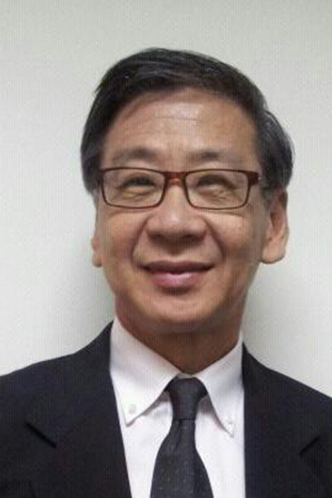 | Mr Khoo graduated from the University of Wales, UK with a LLB (Hons) degree in 1992. He is a Barrister-at-Law of Middle Temple and an Advocate and Solicitor of Singapore Supreme Court.  His areas of practice include commercial and criminal litigation, conveyancing, probate, family law and mental capacity matters. He is currently practising under his own firm AY Khoo Law Chambers.
11 | Steven Lam | 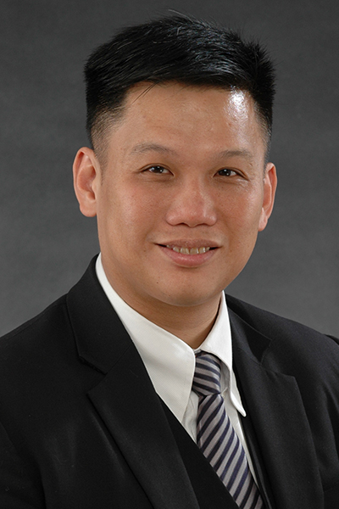 | Steven Lam is an advocate and solicitor specializing in insurance/ reinsurance/ O&G / International shipping & trade / cross border M&A and JV / community law and he is a chartered arbitrator and certified mediator and adjudicator.  Currently He is also a Fellow of London’s Chartered Institute of Arbitrators and Singapore Institute of Arbitrators, and an Associate of the Singapore Institute of Taxation, and a Member of the Singapore Institute of Directors. He was also the Chief Legal Officer / General Counsel of a healthcare provider and also a multinational O&G / Shipping Company, and also volunteers as a mediator at the State Courts, CASE and Singapore Mediation Center for criminal, POHA and civil matters.  Steven is mentioned in Asia Law Profiles as a lawyer familiar with Oil & Shipping matters and has a strong reputation in mediation matters.  (http://www.asialawprofiles.com/pdfs/Directories/33/Singapore-2013.pdf).  During his tenure as a General Counsel of an international MNC, he helmed the legal team that was nominated for the Shipping In-House Team of the Year for the years 2006, 2007 and 2008 for ALB SE Asia Law Awards (which recognises SE Asia's leading law firms and as well as top deals and dealmakers) (ref: http://www.albawards.com/), and the team won the award in 2008.  For his contributions to society he was awarded the Public Service Medal (PBM) by the President of Singapore in 2005, and the Public Service Star (BBM) in 2012.  Further, in 2010, for his legal work, Steven was one of only 2 recipients awarded the “Outstanding Volunteer Award" by the Minister of Law and was awarded the “Minister of Law Appreciation Award” in 2011.
12 | Low Seow Ling | 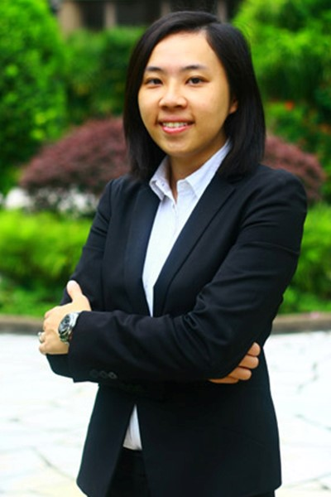 | Seow Ling graduated from the Singapore Management University in 2012, and was admitted as an Advocate and Solicitor of the Supreme Court of Singapore in 2013.  Seow Ling is currently an Associate Director at Eden Law Corporation. Seow Ling believes it isn’t enough to be treated equal before the law. That legal representation ought to be within every individual's reach. Low Bono is essential in achieving this goal, ensuring that legal representation is made available through equitable, affordable and sustainable means.  Seow Ling was admitted as an Advocate and Solicitor of the Supreme Court of Singapore in 2013. Her areas of practice are Matrimonial matters and Estate and Probate Matters. She is a fluent Mandarin Speaker and enjoys playing various musical instruments.
13 | June Lim |  | June is the Managing Director of Eden Law Corporation, a Low Bono law firm founded on June’s firm belief that doing good and a successful legal practice are not mutually exclusive concepts.  Professionally, June has been involved in litigation at all levels of the Singapore Courts, although her principal area of practice has been in the area of matrimonial law.  June has handled a wide spectrum of matrimonial matters: divorces for both high net-worth clients and the man (or woman) on the street, separations, variations of divorce orders, relocation, child abduction and other cross-border issues, custody and access issues, maintenance, personal protection orders and ancillary matters hearings and appeals to the High Court.  June has also handled civil and commercial matters: debt recovery work, breaches of contract, intellectual property matters, defamation, landlord-tenant disputes, employment disputes and non-contentious advisory work.
14 | Luo Ling Ling | 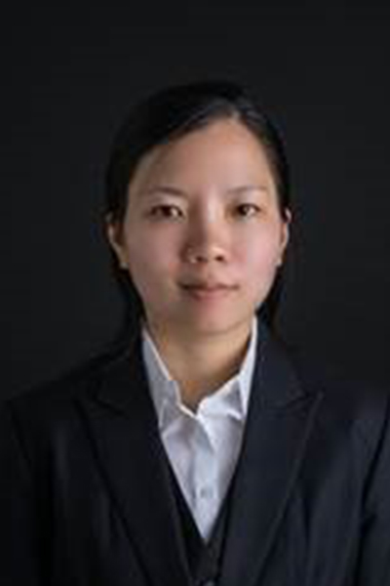 | Ling Ling is a Partner at Aequitas Law, and takes on cases in family and matrimonial law, criminal law, in addition to commercial cases requiring litigation in court. She has experience in contentious matrimonial proceedings involving custody, care and control of children and division of matrimonial assets.  Ling Ling previously served in the Ministry of Social and Family Development, Office of the Public Guardian, as Assistant Director (Legal), drafting and guiding the Singapore government’s policies on the Mental Capacity Act. Notably, she represented the Public Guardian in high profile court cases such as The Public Guardian v Yang Yin & another and The Public Guardian v Kay Swee Pin & another, while holding various appointments. She was also Assistant Director (Professional Deputies & Donees).  As such, she is in the best position to advise high net-worth individuals on wills and lasting powers of attorney, including those who require representation in court.  In commercial law, Ling Ling has demonstrated specialized expertise in obtaining freezing orders for clients, defended Directors for offences under the Securities and Futures Act, Companies Act and CPF Act. She also defended an en-bloc sales committee member for claims against him for alleged breach of fiduciary duties.  Ling Ling also maintains her interest in criminal law by taking up, pro bono, complex criminal matters, and was appointed as Assisting Counsel in the Legal Aid Scheme for Capital Offences in 2012. In 2012, she represented Mr Wang Wenfeng in his appeal against the death sentence.  Ling Ling was called to the Singapore Bar in 2008 and the New York Bar in 2012.  In addition, she is an accredited mediator and was appointed to the Family Panel since 2015, an Expert Panel in the Singapore Mediation Centre. Notably, she mediated a highly-contested divorce matter involving S$40 million of matrimonial assets in various jurisdictions.
15 | Mohammad Rizuan Bin Mohammad Yasin |  | Rizuan graduated from the University of Manchester in 2014. He completed his Relevant Legal Training under the Managing Partner of the firm, Mr. Mohamed Baiross and his Practice Training Contract at B.Rao & K.S Rajah under Mr Fazal Mohamed before being called to the Singapore Bar as an Advocate and Solicitor in 2016.  Rizuan has a keen interest in Civil matters particularly those involving companies and businesses. Rizuan also believes that it is important to ensure that individuals are protected and not left stranded by companies and or businesses that fail to deliver. Further, Rizuan encourages companies/businesses to pen down into contracts, in clear terms, their business agreements.  Rizuan’s wide area of practice since his time as a trainee, has seen him involved in a gamut of Civil matters including those at the High Court. He has also assisted in Criminal (Capital) matters such as Drug Trafficking offences. He also practices Divorce Law (General) and Syariah Law (Muslims) including Muslim Estate Planning (Wasiat and Hibah).  Apart from the aforementioned, Rizuan keeps himself regularly updated on the state of the law in Singapore.
16 | B Rengarajoo | 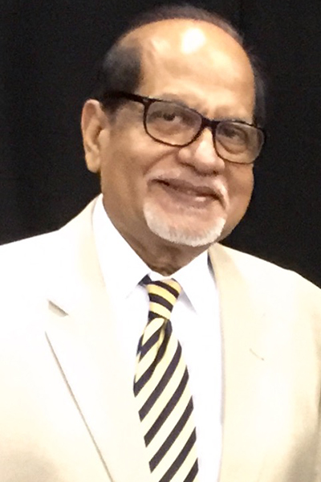 | Mr B Rengarajoo, a former Assistant Superintendant of Police with the Singapore Police Force, was called to the Bar of England and Wales in 1981 after graduating with a LL.B (Hons) from the University of London. In 1983 he was called to the Singapore Bar. Since then, he has had 33 years of experience spanning a variety of Civil, Commercial and Criminal Litigation, as well as Alternate Dispute Resolution (ADR). He subsequently obtained his Master of Laws from the National University of Singapore in 1999.  Rengarajoo is a Chartered Arbitrator and Fellow of both the Chartered Institute of Arbitrators (CIArb) and the Singapore Institute of Arbitrators (SIArb). He is on the Arbitration Panels of Singapore International Arbitration Centre (SIAC), CIArb, SIArb, Kuala Lumpur Regional Centre for Arbitration (KLRCA), the Singapore Institute of Surveyors and Valuers and the Singapore Law Society Arbitration Scheme. He is also a member of the Disciplinary Panel for the Council of Estate Agencies.  He has acted as both sole arbitrator and co-arbitrator in domestic and international commercial arbitrations under the various Arbitration Rules.  Rengarajoo, a Principal Mediator with the Singapore Mediation Centre, has attended several mediation courses, both in Singapore and abroad. He was the only participant from Asia who attended and successfully completed the 1st European Mediation Training for Practitioners of Justice (EMTPJ), a European Union sponsored training programme under the EU Directive 2008/52/EC. Rengarajoo has acted as a mediator in more than 120 cases from the Singapore Mediation Centre, State Courts Centre for Dispute Resolution, Community Mediation Centre, Small Claims Tribunal and the Consumers Association of Singapore.  Rengarajoo has a passion for teaching and is on the CIArb's Approved Faculty List as a tutor, examiner, moderator and assessor for Arbitration, International Arbitration and Mediation courses, and has taught various arbitration modules. He is also on the Panel of Tutors for arbitration courses run by SIArb . Currently he sits on the Board of Directors of the CIArb, Singapore Branch.
17 | Hany Soh |  | Ms Hany Soh joined MSC Law Corporation as an Associate when it commenced practice on 1 January 2016. She became a Director of MSC Law Corporation on 1 January 2017.  Hany graduated in 2011 from the University of Liverpool with a Bachelor of Laws (Second Class Upper Honours) and was admitted as an Advocate & Solicitor of the Supreme Court of Singapore in 2013. Hany also holds a Diploma in Law & Management from Temasek Polytechnic.  Hany’s main areas of practice include: Civil & Commercial Litigation, Criminal Law, Family Law, Probate & Administration, Corporate Law and Intellectual Property Law.  Hany routinely represents clients in matrimonial disputes at the Family Justice Courts as well as criminal cases, at both the State Courts and the High Court. In the course of her practice, Hany has facilitated the registration of several prominent trademarks.  Hany sits on the Young Lawyers’ Committee, Criminal Legal Aid Scheme Committee and Community Legal Clinic Committee of the Law Society of Singapore.  Hany is an active grassroots leader in Bukit Panjang SMC. She is the Feedback Committee Chairman of Bukit Panjang Citizens’ Consultative Committee since 2016. She was the Chairman of Bukit Panjang Zone 2 Residents’ Committee (RC) from 2013 to 2016 and now assists the RC as its Vice-Chairman. She has also set up a monthly community legal clinic in the RC Centre, with the help of fellow members of the bar, providing pro bono legal advice to Bukit Panjang residents since 2014.  Aside from her contributions on the grassroots level, Hany is the Young PAP Chairman of the People’s Action Party Bukit Panjang Branch since 2015, and was elected into the PAP HQ 2017/2018 Executive Committee.  Hany also serves as the Legal Advisor for a Chinese temple located at the north-western part of Singapore and sits on the School Advisory Committee of the Zhenghua Primary School.
18 | Samuel Seow | 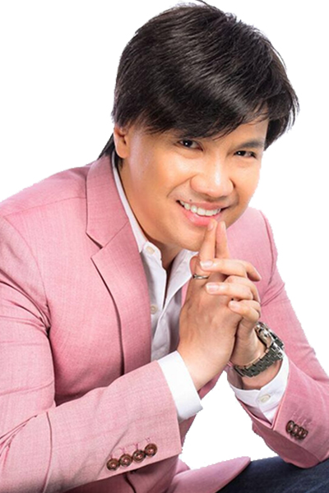 | In 2005, armed with a cash loan and the support of 2 friends, Samuel Seow incorporated Samuel Seow Law Corporation ("SSLC") with a mission to change the way legal practice is conducted – where the indifference and general "stuffiness" people associate with legal practice is replaced with genuine warmth and compassion. These lofty ambitions started humbly. Before incorporation, the founding partners of the law corporation would meet weekly at the McDonalds outlet in Clarke Quay to strategise and plan for the future of the business. When the law corporation was finally incorporated on 17 March 2005, the lawyers first worked out of the small one–bedroom apartment in which Samuel had then lived.  Samuel Seow, at that time, became the Managing Director of the new business and was far from the "celebrity lawyer" he has been dubbed by the local press to be today. He was a young, nervous, struggling entrepreneur compelled to face the challenges of entrepreneurship head on as he navigated SSLC into safe waters at a time when the Asian Financial Crisis loomed.  Today the law corporation has surpassed expectations and terse comments that "Singapore is never going to need an entertainment lawyer" and has garnered accolades and awards both locally and internationally, and has grown beyond its position as "Singapore‘s first media law firm" to a respected, full service medium–sized legal practice. Through positive word-of-mouth and through savvy marketing of SSLC and Samuel Seow as a public persona, SSLC is, today, a well-recognised name in the legal and entertainment industries. For his achievements, Samuel was awarded the Spirit of Enterprise award in 2011. For years, SSLC has been ranked annually in the prestigious Asia-Pacific Legal 500, where Samuel is listed as a "significant individual". SSLC has also been recognized as "Media & Entertainment Law Firm of the Year Award in Singapore" as part of the Global Awards. For its contributions exceeding S$300,000 annually to the arts, the National Arts Council has awarded to SSLC the "Distinguished Patron of the Arts Award " every year since 2010. Samuel is also today the Co-Chairman of the Theatre Practice and nominated to sit on the board of assessors for the Major Grants Panel of the National Arts Council.  SSLC has also stretched its wings outside of Singapore to neighbouring Malaysia, where its Malaysian associated office, Seow & Associates (which is also featured in the Asia Pacific Legal 500), today repeats the success story of SSLC and represents some of the most exciting media companies across the causeway, including the Pinewood Iskandar Studios, an integrated media production studio facility which opened its doors to the world on 14 June 2014.  Samuel has been keenly involved in all aspects of Samuel Seow Law Corporation since its incorporation and remains committed to building a legal practice upon the foundations of passion, creativity and love.
19 | Sujatha Selvakumar | 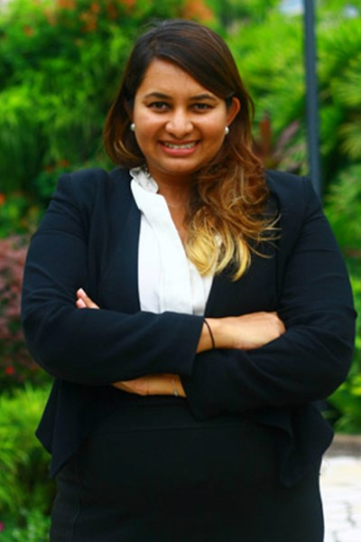 | Sujatha Selvakumar is an Associate Director at Eden Law Corporation. Sujatha believes that a strong and reliable justice system is critical to a secure society and a growing economy. The success of our society relies in large part on the trust we all put in the rule of law and the knowledge that the courts will be there to enforce our rights should something go wrong. Hence is it equally critical that legal representation is within reach for every individual.  Sujatha was admitted as an Advocate and Solicitor of the Supreme Court of Singapore in 2011. Sujatha has extensive experience in civil and commercial litigation. She was one of five pioneer Criminal Legal Aid Scheme Fellows in 2015 and continues to assist those in need.
20 | Richard Siaw | 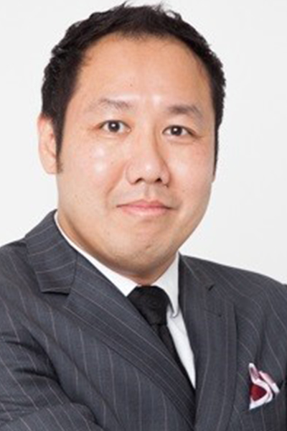 | Richard is a general litigator and focuses his practice on commercial, criminal and family matters at JusEquity Law Corporation, Singapore. He also advises high net worth clients on legacy planning and migration matters.  He is the columnist of 《萧遥法外》at 随笔南洋 (a prominent Singapore based blog featuring Chinese literary works and current affairs commentaries) where he regularly contributes articles on law. Richard is also a community host with Rediffusion Singapore (a company which pioneered cable radio in Singapore) and a regular guest speaker of Singapore radio station 88.3 on legal topics.  Prior to practicing law, Richard spent more than 16 years in business, primarily in the international human resources and migration sectors. He travelled extensively to Australia, China, Ireland and Saudi Arabia and over the years has built up a good knowledge in international business and cross border business transactions in those countries.  Effectively bilingual in English and Chinese, Richard is honorary counsel to several private enterprises and non-profit organisations in Singapore. He is also a Singapore Ministry of Education-registered part-time lecturer for conducting courses with local tertiary institutions. Between 1995 and 1997, he was an Assistant Superintendent with the Singapore Police Force.  Richard graduated in 1994 from Monash University Australia with 1st Class Honours degree in Business and obtained a Master’s degree in Management from University of Cambridge in 1998. He was conferred with a Juris Doctor degree (High Merit) by the Singapore Management University in 2013. He was admitted to practice law in 2014.
21 | Patrick Tan | 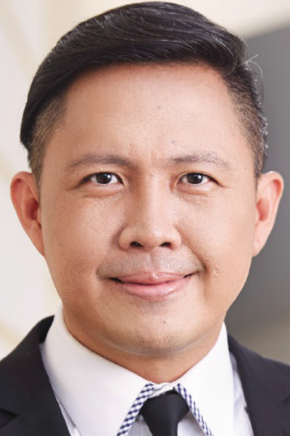 | Patrick Tan is the founder and Chief Executive Officer of Fortis Law Corporation. His areas of practice include commercial litigation and arbitration, wealth management, and private client matters. He is a Notary Public Commissioner for Oaths, a Fellow of the Singapore Institute of Arbitrators, as well as an accredited Associate Mediator, appointed by the Singapore Mediation Centre and the Primary Dispute Resolution Centre of the State Courts of Singapore. He also currently serves as a Volunteer Mediator for Small Claims Tribunal, State Courts of Singapore, as well as State Courts-SMC panel of mediators for the Volunteer Mediator Programme (Magistrate Complaints). In addition, he is also a Legal advisor for Singapore Estate Agents Association.  Patrick obtained his LL.B. (Hons) at the Nottingham University, where he received top honours, clinching several academic awards in land law, company law and partnership law.  In 2005, Patrick was nominated for the Spirit of Enterprise Award in Singapore for founding M/s Patrick Tan & Associates (now known as Fortis Law). In 2007, Patrick steered the firm into becoming the firstlaw firm in Singapore to be accredited with the PrimeLaw Practice Management Excellence Standard awarded by the Law Society of Singapore. It is also the first law firm to be awarded the Volunteer of the Year Award 4 times in a row from 2010 to 2013 by the Law Society of Singapore.  Patrick speaks fluent English, Mandarin, Hokkien and Cantonese. In his spare time, he enjoys golfing, fishing, running, swimming, cycling and travelling.
22 | Lionel Tan | 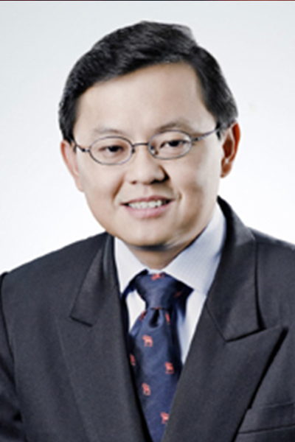 | Lionel started out his career in law as a Deputy Public Prosecutor and concurrently held the appointment of Assistant Director of the Computer Information & Systems Department of the Attorney-General’s Chambers. Since joining private practice he has been involved in various high profile commercial and criminal litigation cases and has advised clients on a wide spectrum of commercial and criminal matters.  He has a keen interest in the field of Information Technology Law, with special emphasis on the developing area of litigation practice in the Information Technology arena. He has been involved in cases dealing with Internet defamation, Internet fraud, on-line security breaches, trade secrets and misappropriation of confidential information, telecommunication regulatory issues and software implementation and website development disputes. He advises and represents clients on intellectual property matters relating to trade mark and copyright infringements. He also advises and represents clients on IP matters relating to brand protection, licensing and franchising issues. He also advises clients on compliance measures in relation to the Personal Data Protection Act (PDPA) and is a member of the National Council of Social Services’ Workgroup for the PDPA. Lionel also advises and speaks regularly on the legal issues involving Social Media. His varied interest also encompasses advising on Sports Law matters and he held the appointment of Vice-Chairman of Etoile Football Club, the first European professional football club to play in the S-league in Singapore.  Lionel graduated from the University of Hull, United Kingdom in 1992 with a Second Upper degree in Law. He was awarded the Sweet & Maxwell Law Prize for that year. He pursued a postgraduate degree at the University of Oxford and was conferred a Bachelor of Civil Law. He has also completed the Certified IT Project Manager Assessment course conducted by the Institute of System Science.
23 | Tan Jin Song | 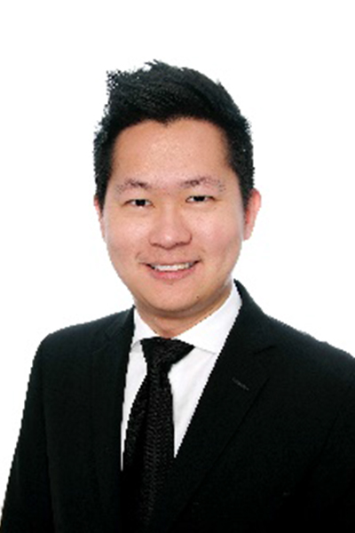 | Jin Song is a Director at Kel LLC.  Jin Song has acted for clients in a range of criminal matters, including regulatory and immigration  offences as well as drug related charges. He has been second chair and represented accused  persons in capital cases as well as conducted a variety of civil and criminal trials and hearings in both  the State Courts and Supreme Court. Jin Song’s experience also includes family/matrimonial work  and he is an active volunteer at the legal clinic established by the Sexual Assault Care Centre, which  aims to assist victims of serious sexual offences.  Jin Song is regularly invited to speak in schools and institutions on topics relating to young persons/  children with special needs and the criminal justice system in Singapore.
24 | Tan Shen Kiat | 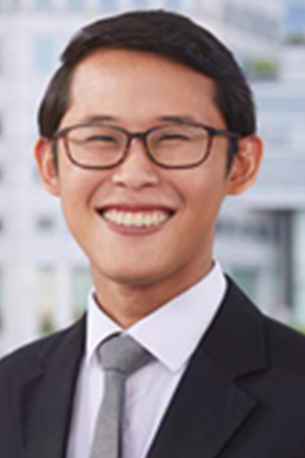 | Shen Kiat is the Legal Advisor of FortisWills and FortisCare, advising them in their daily operations. He is also a practicing community lawyer within the Private Client Practice Group (“PCP”) of Fortis Law Corporation.  As part of his private-client practice, Shen Kiat assists a variety of clients to plan for the present and future generations through the design and creation of trusts and other anticipatory decision-making instruments, such as but not limited to Wills (a form of testamentary trust) and Lasting Power of Attorney (“LPA”) under the Mental Capacity Act (in his opinion, the best piece of legislation to be passed for the community in recent years). Together with the rest of his team, Shen Kiat also serves the community via the practice of trusts and probate, family, crime, real estate and personal injury and accidents law.  Occasionally, his work involves house-calls or hospital visits where sensitivity and empathy are often required. Through the sharing of lives, Shen Kiat believes that he and his clients help each other to number their days – a pre-requisite for a heart of wisdom.  Shen Kiat is also very active in pro bono work, which he sees as his way of giving back to the community in which he serves. He is passionate in defending the poor and the oppressed, particularly those who suffer injustice, but with no means of fighting back.  Apart from his legal work, Shen Kiat frequently speaks at various public and private events on topics such as Wills and Probate, as well as Lasting Power of Attorney.  Two principles guide his approach to life:  1) Act Justly, Love Mercy and Walk Humbly with his God  2) Look upon the world as his neighbour.
25 | Sarah-Mae Thomas | 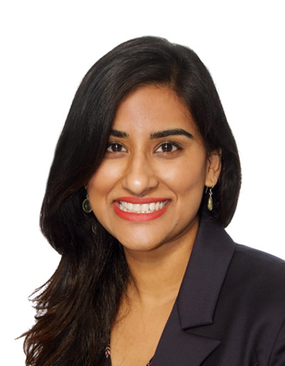 | Sarah-Mae is a Legal Associate at Ann Tan & Associates. Sarah-Mae is an Australian and Singapore qualified lawyer. Her primary area of practice is in dispute resolution. She has assisted in contentious matters at various levels of Singapore's Courts and Alternative Dispute Resolution processes in a variety of areas, including Workmen’s compensation, Motor vehicle accidents, Family Law and Mental Capacity Act matters.  With respect to Family Law matters, Sarah-Mae regularly advises and acts for both Singaporean and foreign clients in matrimonial proceedings including contentious and non-contentious divorce proceedings. This includes disputes on custody of and access to children, maintenance for wives and children, the division of matrimonial assets and family violence. She also represents clients during mediations and strongly believes in encouraging her clients to resolve matrimonial breakdowns as amicably as possible with a long-term view on family relationships.  With respect to personal injury matters, Sarah-Mae specialises in industrial accidents and has advised those seeking compensation as well as Insurance companies. She is familiar with both Common Law claims and claims under the Ministry of Manpower.  “I am passionate about fighting for justice and want to make a difference in the lives of others, wherever possible.”  Sarah-Mae graduated from Monash University with an LLB (Hons) / BA degree in 2012. Prior to being admitted to the Singapore Bar in 2015, Sarah-Mae was practising personal injury litigation in Melbourne, Australia for two years.  She is a member of the Singapore Association of Women Lawyers and sits on the executive committee. She is also a regular volunteer at Thomson Community Centre Legal Clinic.
26 | Abdul Wahab |  | Wahab graduated from the University of Leeds in 2013 and was admitted to the Singapore Bar in 2015. His focus is on general litigation and dispute resolution. His practices runs the gamut from Civil to Family law as well as Syariah and Criminal matters.  Wahab also undertakes solicitors work in drafting corporate documents as well as probate and trust matters.  He believes strongly that everyone is entitled to access to legal services. He is a patient listener who is dedicated in ensuring a good outcome for his clients.
27 | Cory Wong | 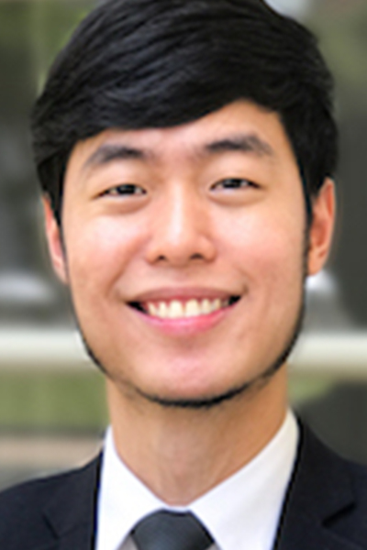 | Cory is an Associate in the Private Client Practice Group of Fortis Law Corporation. He specialises in criminal law and works directly under prominent criminal lawer Josephus Tan.  Cory handles a whole array of white and blue collar matters, from theft to regulatory crimes and from disorderly behaviour to homicide.  Cory believes in second chances for the deserving and takes on cases involving offenders from all walks of life. However, reality may be harsh and second chances may not come readily. Cory thus believes in spreading criminal law literacy at the grassroots in the hopes of averting crime before it happens.  And for those who have fallen prey to the allures of crime or for those who staunchly maintain their innocence, Cory believes in protecting their interests to the fullest extent possible under the law.  Cory was previously a police officer and had spent much time interacting with the community. As a lawyer, he continues to devote countless hours to speaking at community events.  Cory graduated from the University of Warwick (UK) and is admitted as an Advocate and Solicitor in Singapore. He is fluent in English and Mandarin.
28 | Gerald Mursjid Wiyatno | 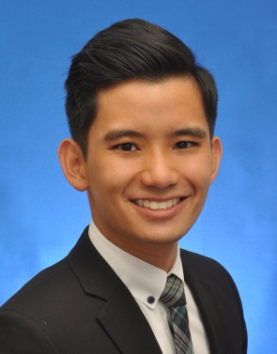 | Gerald Mursjid is Gateway Law Corporation’s senior associate and employment law specialist.  He has experience in all aspects of employment and immigration legal work, both contentious and non-contentious. He advises on all things employment (minimum benefits and protections, workplace discrimination, health and safety, employment- aspects of tax, insolvency and personal data and ect) and all types of employment documentation. His work extends to undertaking employment due diligence work.  On the contentious front, he has acted for employees in claiming against organisations, and has also acted for organisations in respect of regulatory non-compliances and audit.  As part of his public outreach, he has published numerous Employment Law Client Updates and given employment law public presentations. Channel NewsAsia has interviewed him multiple times for his professional views on employment matters.

